MACKEREL MODEL

Abstract:
This report outlines the development and refinement of Mackerel models for classifying the freshness of fishes as either "bad" or "good." Over six iterations (V1 to V6), the models have undergone enhancements in various aspects to improve accuracy and reliability. This report presents a detailed analysis of each version, including the challenges encountered, solutions implemented, and the corresponding accuracies achieved.

High-Level Tech Stack:
Common Image processing libraries, Frameworks and Development platforms used (These are common for all the 6 versions of Mackerel):
- Deep Learning Framework: Tensorflow with Keras, Pytorch
- Programming: Python
- Image processing libraries: OpenCV, Pillow, Ultralytics, Scikit-Image
- Data visualization and Plotting: Matplotlib, Seaborn
- Development platform: Jupyter notebook

Metrics used for Model Evaluation:
- Confusion Matrix:
  - The matrix contains information about true positive (TP), true negative (TN), false positive (FP), and false negative (FN) predictions made by the model.
  - TP: Actual positive cases correctly predicted as positive.
  - TN: Actual negative cases correctly predicted as negative.
  - FP: Actual negative cases incorrectly predicted as positive (Type I error).
  - FN: Actual positive cases incorrectly predicted as negative (Type II error).
  - The values in the confusion matrix can be used to calculate various evaluation metrics such as accuracy, precision, recall, and F1-score.

- F1-Score:
  - The F1-score is a metric commonly used for evaluating the performance of classification models, particularly when dealing with imbalanced datasets.
  - It is the harmonic mean of precision and recall, providing a single score that balances both metrics.
  - Precision measures the accuracy of positive predictions, while recall measures the ability of the model to capture positive instances.
  - The F1-score reaches its best value at 1 and worst value at 0. A higher F1-score indicates better model performance in terms of both precision and recall.
  - It is calculated using the formula:
f1 = 2 * (precision * recall) / (precision + recall)

Model Development Overview:

- MACKEREL-V1: (24-Aug-23 to 5-Oct-23)
- MODEL ARCHITECTURE: The V1 architecture is as follows.
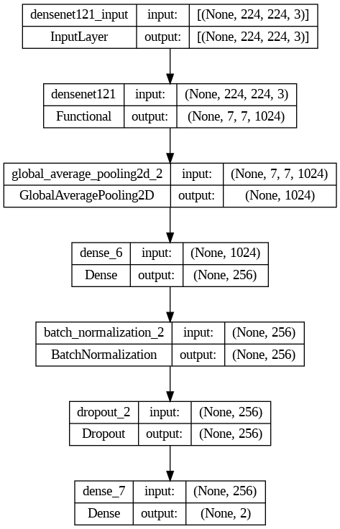

- Model parameters:
  - Batch size – 32
  - Dropout – 0.5
  - Output Activation function – Softmax
  - Metric – F1 score
  - Loss – Categorical cross-entropy
  - Call-backs – Learning rate schedule, Early stopping

- Dataset size:
  - Data augmentation - None
  - Train – 3237
  - Validation – 1078
  - Test – 1082
  - Unseen test – 1286

- Image pre-processing:
  - Most of the images collected during this period were grouped images. But the task was to predict the freshness for Single fish.
  - We had to include the cropping as the first step of our pre-processing step.
  - Then the next pre-processing step was to resize the images, we used size (224, 224).
  - To preserve the size variations of the fishes, we resized the images with preserved Aspect ratio.
  - Since we were preserving Aspect ratio for cropped images, we had to pad the images with white pixels in the blank area.

- Validation of Version V1:

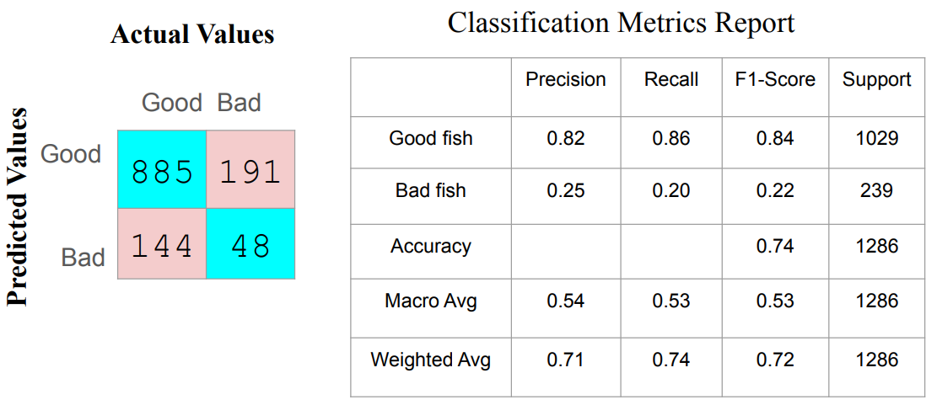

- Problems with Version V1:
  - The model achieved overall accuracy of 74%, But the recall and precision rates were too low for “BAD” class.
  - One more Major problem of this model was, it could not classify the fishes with damages and cuts as “BAD”.
  - This ‘Damage detection’ was included in the Second version of the Mackerel

- MACKEREL-V2: (6-Oct-23 to 12-Oct-23)
All the pre-processing steps, Model architecture & other parameters were exactly like Mackerel-V1. The only thing was it was stacked with ‘Damage detection’ and ‘Eye turbidity’ detection & Small change in number of neurons and dropout rate.

- MODEL ARCHITECTURE:
The pre-processed images are first passed through Eye Turbidity and Damage Detection then to CNN architecture.
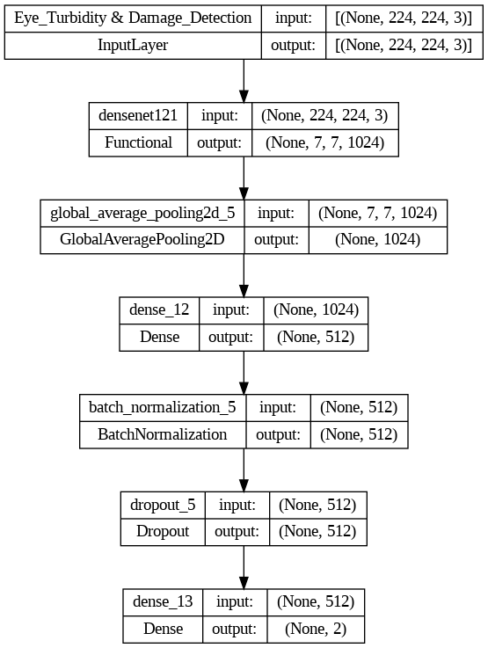

- Model parameters:
  - Dense - 512
  - Dropout – 0.7

- Dataset size:
  - Unseen test – 60

- Validation of Version V2:

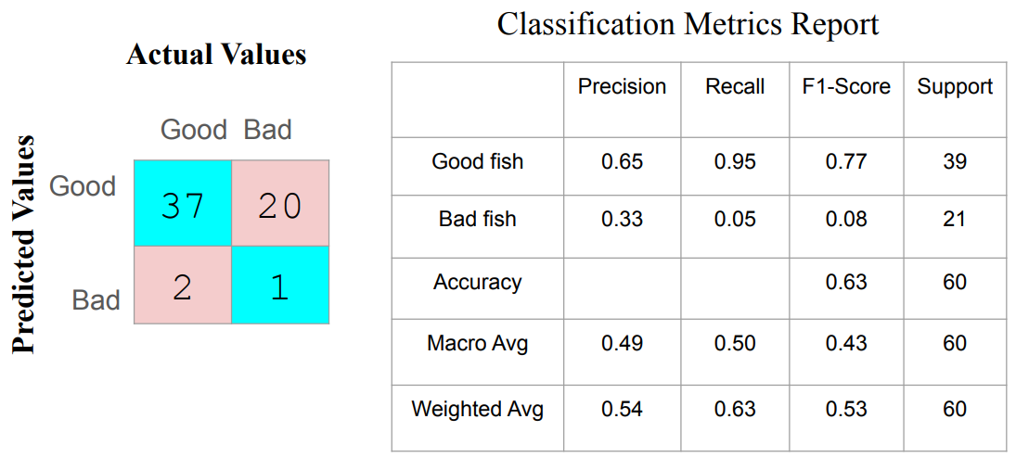

- Problems with Version V2:
  - Low performance towards “BAD” class persist.
  - Overall accuracy was only 63%.
  - Only the CNN architecture was replaced to older version which was having 74% accuracy.

- MACKEREL-V3: (13-Oct-23 to 22-Oct-23)
This V3 version is only replacement of the V1 version, including the “Damage detection & Eye turbidity”.

- Dataset size:
  - Unseen test – 81

- Validation of Version V3:
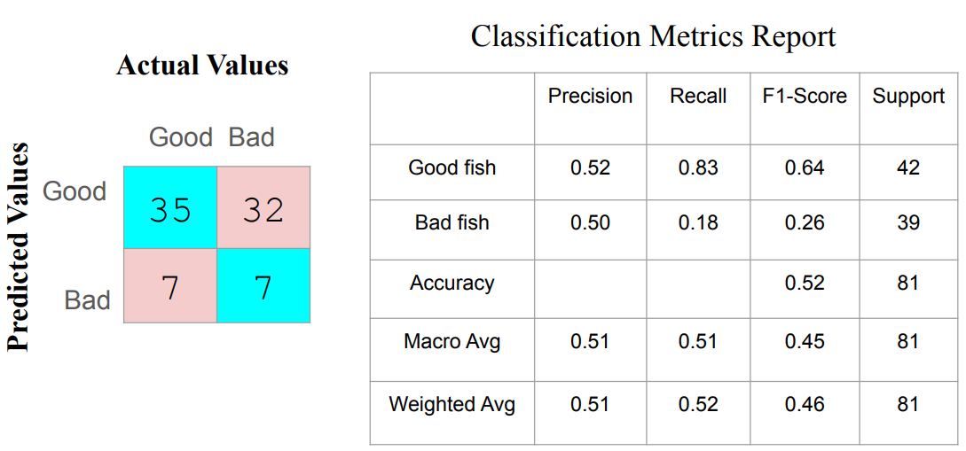

- Problems with Version V3:
  - Low performance towards “BAD” class persist.
  - Overall accuracy was only 52%.
  - It was again lower than V2.
  - It was also noticed that the Damage detection model was not working so well.

- MACKEREL-V4: (23-Oct-23 to 31-Dec-23)
In this version of Model everything was same as V3 version, only in “Damage detection” we made changes, that previously the “Damage detection” model used cropped images. But in this version, we started to pass the segmented images.
For image segmentation we used “YOLO-V8” model, from ‘Ultralytics’ library which is based on “Pytorch” framework.
The “Eye turbidity detection” model was removed.

- Dataset size:
  - Unseen test – 1458

- Damage detection model:
  - Image type – Segmented image

- Validation of Version V4:
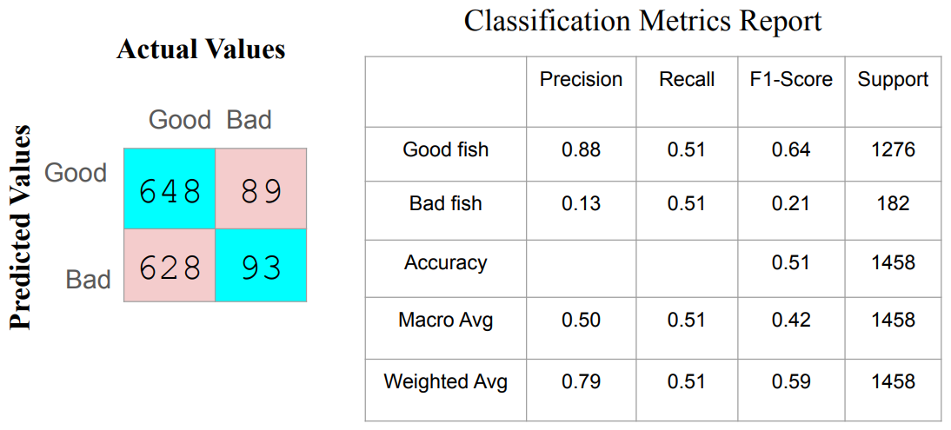

- Problems with Version V4:
  - Low performance towards “BAD” class continued.
  - In this version recall for “GOOD” class was also dropped significantly.
  - Overall performance was very bad with only 51% accuracy.
  - It was also an evaluation on the large data and it clearly suggests the model is performing poorly.
  - To solve this issue, the dataset size was increased and We started to train model with segmented images in the V5.

- MACKERLE-V5: (01-Jan-24 to 15-Jan-24)

In this version of the model, there has been significant changes, both in terms of dataset size and Model architecture.

- Dataset size:
Major changes done in the dataset:
- Firstly, the data augmentation was used.
- In this version, we have only used the single fish images, instead of group fish images.
- Till now in the previous versions, we have used cropped images that too with preserved aspect ratio. But in this version, we have used segmented images without preserving the aspect ratio.
- The background for segmented images is black.

  - Data augmentation - Done
  - Train – 2865
  - Validation – 955
  - Test – 955
  - Unseen test – 425

- Image pre-processing:
  - In this version we have used segmented images with black background. And, this pre-process was common among the other two models. So that uniformity is maintained.
  - After segmentation we used “Densenet pre-process input” function to pre-process the images.

- Model parameters:
There were also few significant changes in the model architecture and parameters. Listed them below
- 3 Dense layers were used.
- For the first time utilized transfer learning with fine tuning for DenseNet121.
- In the fine-tuning process 4 out of 5 blocks of DenseNet121 model were frozen. Only the last block was set to train.

  - Batch size – 32
  - Dense – [128, 64, 32]
  - Dropout – [0.4, 0.3, 0.2]
  - Output Activation function – Sigmoid
  - Metric – F1 score
  - Loss – Binary cross-entropy
  - Learning rate – 1e-5

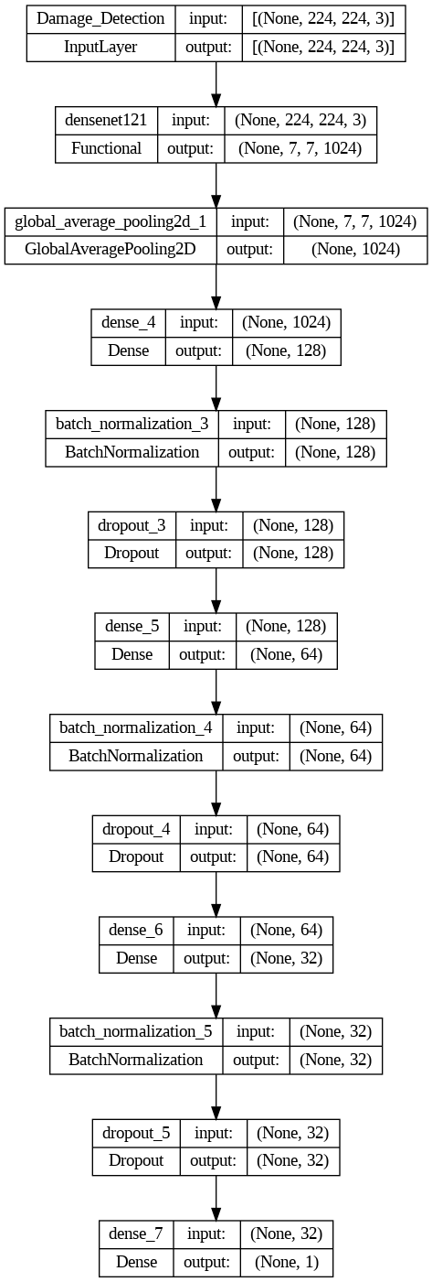
- MODEL ARCHITECTURE: The V5 architecture is as follows.

- Validation of Version V5:
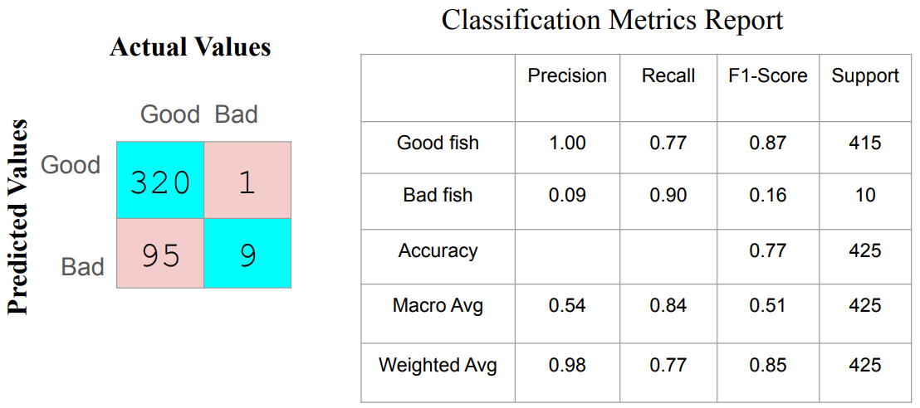

- Problems with Version V5:
  - This model was performed well compared to all the previous with overall 77% accuracy.
  - The precision for “Good” class was 100% but the recall rate was little lower with 77%.
  - But the precision for “Bad” is too low with only 9%.
  - But again, the testing done on “Bad” class was low.
  - To improve the Precision for “Bad” we had to retrain the model with updated dataset. Which was done in next version.

- MACKERLE-V6: (16-Jan-24 to 04-Mar-24)
This version also has the identical architecture to the previous version V5.

There are only two changes:
- Dataset size was increased
- In fine tuning, 3 out of 5 blocks were frozen and last 2 blocks were set to train.

- Dataset size:
- Data augmentation - Done
- Train – 6505
- Validation – 1858
- Test – 931
- Unseen test – 774

- Validation of Version V6:

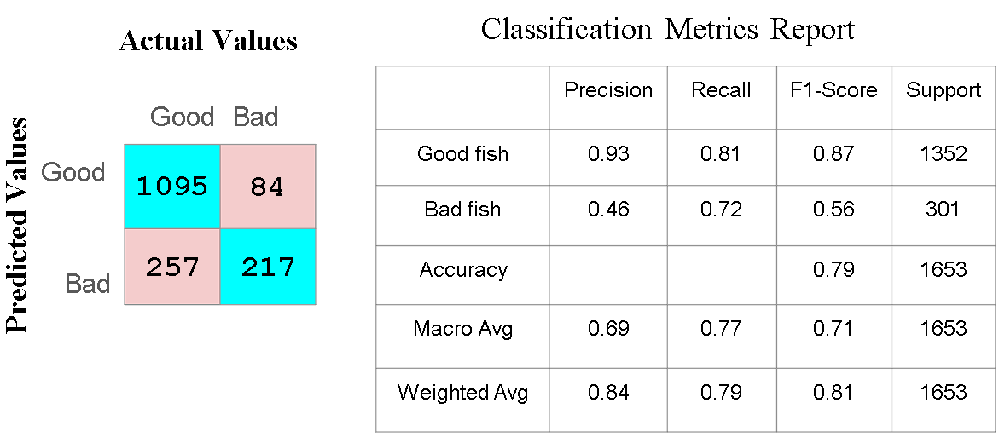

- Problems with Version V6:
  - So far it has an overall accuracy of 79%.
  - The precision for the “Bad” class is still lower with only 46%.

- MACKERLE-V7: (05-Mar to 27-Mar-24)
This also has the identical architecture to the previous version V6.

There is only one change:
- Dataset size was increased

- Dataset size:
- Data augmentation - Done
- Train – 8531
- Validation – 2914
- Test – 2922
- Unseen test – 471

- Validation of Version V7:
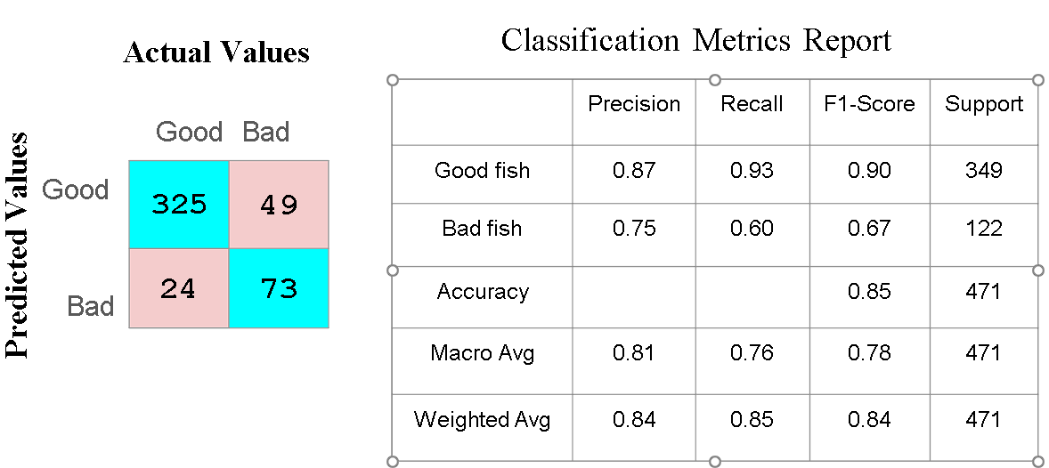

- Observations of Version V7:
  - This is the latest version of the Model that is currently running in the Mobile app.
  - So far it has an overall accuracy of 85% as of till 19th MAR 2024.
  - The recall for the “Bad” class is still low with only 60%.
  - The testing is still under progress and currently tested on small amount of data of only 471 images.

- MACKERLE-V8: (28-Mar to 01-April-24)
This is the same V6 model (Downgraded)

- MACKERLE-V9: (01-April to 07-June-24)
The softness model is still the same (V6) only the Damage detection model was updated and the result was still the same.

- MACKERLE-V10: (08-April to 17-July-24)
The softness model architecture was same but trained with the updated dataset.

- Dataset size:
- Data augmentation - Done
- Train – 10513
- Validation – 3162
- Test –3170
- Unseen test – 943

- Validation of Version V10:
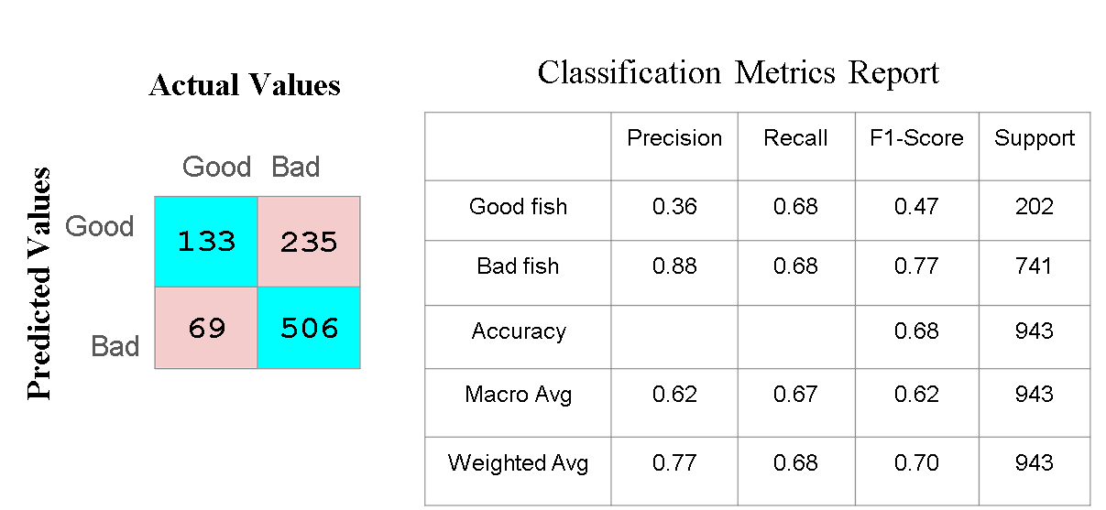

- MACKERLE-V11: (17-July to 28-Oct-24)
The softness model architecture was same but trained with the updated dataset.

- Dataset size:
- Data augmentation - Done
- Train – 11777
- Validation – 3320
- Test –3328
- Unseen test – 402

- Validation of Version V11:
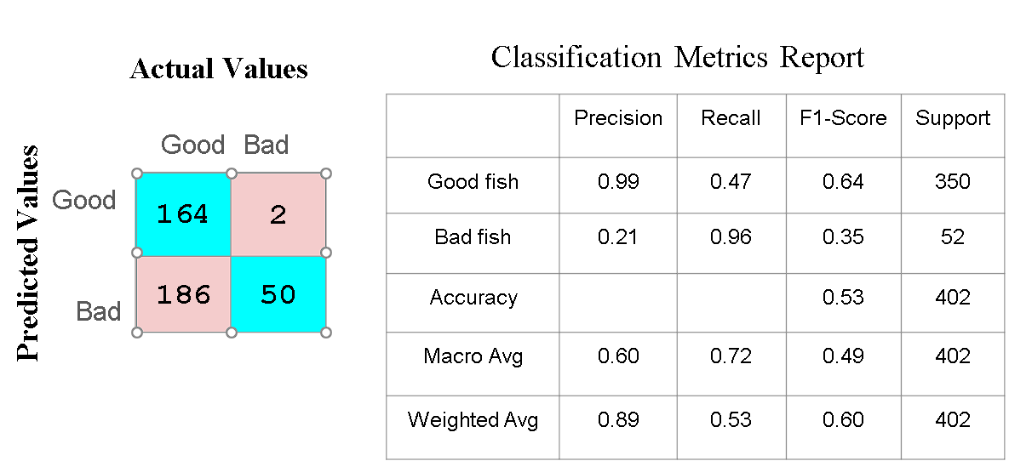

- MACKERLE-V12 and 13: (28-Oct to 24-Dec-24)
These two versions were the same V11 version only the backend was being changed for image compression techniques.

- Dataset size:
- Data augmentation - Done
- Train – 11777
- Validation – 3320
- Test –3328
- Unseen test – 1047

- Validation of Version V13:
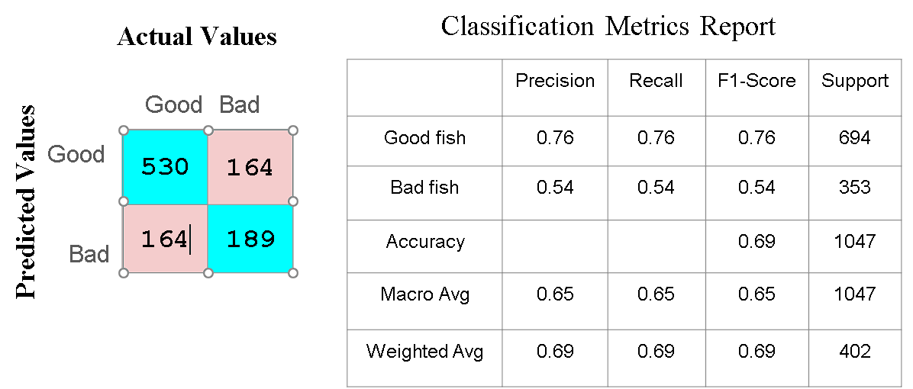

- MACKERLE-14: (24-Dec to Present)
This is the latest version of the Mackerel model at present, this model also uses all the same parameters. The dataset was redistributed for train, validation and test. And for this model version the optimized image compression was used which is currently giving very good results.
- Dataset size:
- Data augmentation - Done
- Train – 22726
- Validation – 2912
- Test –2901
- Unseen test – 520

- Validation of Version V14: (Test)
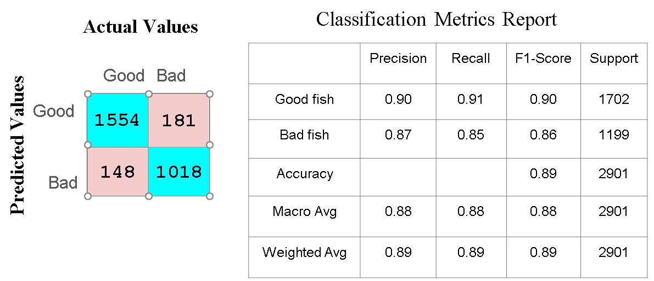

- Validation of Version V14: (Unseen)
